CM3010 DADT mid-term report

(2024 April)

Table of Contents
References 2
commands – LAB 3
commands 7
Stage 1. Find and critique a dataset 15
Stage 2. Model your data 23
Stage 3. Create the database 27
Stage 4. Create a simple web application 28
Extra stage 29

6.

Important!
MY PROJECT ON IN THE LAB ENVIRONMENT CAN BE FOUND AT: /var/lib/mysql/learner_mysql/Project
Reason for changing the folder was related to default behagiour of the lab evrioment that searched for the data to be imported in the default folder

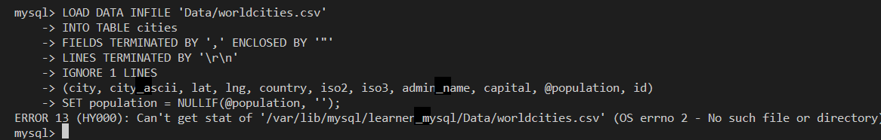
sql> LOAD DATA INFILE 'Data/worldcities.csv'
-> INTO TABLE cities
-> FIELDS TERMINATED BY ',' ENCLOSED BY '"'
-> LINES TERMINATED BY '\r\n'
-> IGNORE 1 LINES
-> (city, city_ascii, lat, lng, country, iso2, iso3, admin_name, capital, @population, id)
-> SET population = NULLIF(@population, '');
ERROR 13 (HY000): Can't get stat of '/var/lib/mysql/learner_mysql/Data/worldcities.csv' (OS errno 2 - No such file or directory)

My Coursera LAB project link

https://hub.labs.coursera.org/connect/sharedwrkzgghp?forceRefresh=false&path=%2F%3Ffolder%3D%2Fhome%2Fcoder%2Fproject&isLabVersioning=true

Introduction
The main idea for this project comes from my current work which is realted to the commercial aviation. Whenever any commercial flight of an airplane is taking place there are very strrict requrements related to chow much fuel has to be taken to complete this flight.

One of the main components of that is selecting an one or more alternate airports (ALTN) instead of the destintion airport (DEST), where an aircraft can land when the destination airport becomes unavailabel for any reason during the flight. Those airports are preferably within 1 hour flight time from the main one which may be around 200NM from the DEST.

The idea for my database is that by querying it for the DEST I will be able to get the list of ALTNs around the destination airport. The airports need to meet specific criteria such as runway length of at least 2200 m and it has to be available for civilian aircraft.
Also, airports used by commercial aviation are identified by three-letter IATA code or four-letter ICAO codes e.g LWH or EGLL for London Heathrow airport. ( IATA stands for: International Air Transport Association and ICAO: International Civil Aviation Organization. ). As an additional feature I want to be able to find airports based on the city names instead of the ICAO or IATA codes.
The database was created by mergingo together data on all airports, runways and cities on the planet. Also data contain some additional information which can be useful beyond the primary goal, for example population of each city, information about countries and continents on which they lay, or administrative regions or geographic dividion of each counry.

Sources of the data
The two main sources of the data were:

- https://ourairports.com/data/

According to the About section:
OurAirports is a free site where visitors can explore the world's airports, read other people's comments, and leave their own. (...)
The site is dedicated to both passengers and pilots. You can create a map of the airports you've visited and share that map with friends. You can find the closest airports to you, and discover the ones that you haven't visited yet.

Behind the fun and features, OurAirports exists primarily as a public good. When Australia forced the US government to shut down public access to its Digital Aeronautical Flight Information File (DAFIF) service in 2006, there was no longer a good source of global aviation data. OurAirports started in 2007 primarily to fill that gap: we encourage members to create and maintain data records for airports around the world, and they manage over 40,000 of them. Many web sites, smartphone apps, and other services rely on OurAirport's data, which is all in the Public Domain (no permission required).

This suggests that data on this website is maintained by enthusiasts, rather then by any governmental institution, and at some instances need to be taken with some level of caution. This is also mentioned in Terms of Use secton:
All data is released to the Public Domain, and comes with no guarantee of accuracy or fitness for use.

That means:
“Public domain” refers to works in which copyright has expired or where the copyright owner has made a clear declaration that they will not assert copyright in the work.
according to the Queen`s University Library (https://library.queensu.ca/help-services/faqs/2446)

On the other hand this is only one free of cost source of such data I could find. I also had used it in my earlier project but in much more limited scope.

Also, the data seem to be very recent. Below I marked the datasets that I have used.
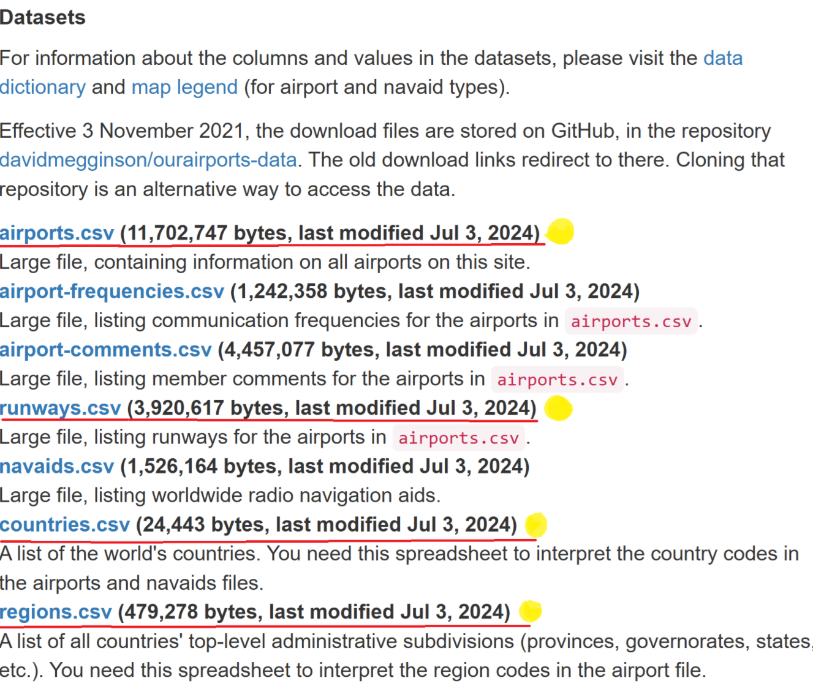

- https://simplemaps.com/data/world-cities
According to the information on the website:
SimpleMaps.com is a product of Pareto Software, LLC. © 2010-2024.
They offer:
(...) simple, accurate and up-to-date geographic databases of places around the world (...)

Regarding cities database:
We're proud to offer a simple, accurate and up-to-date database of the world's cities and towns. We've built it from the ground up using authoritative sources such as the NGIA, US Geological Survey, US Census Bureau, and NASA.

The company offer three version of the cities database.

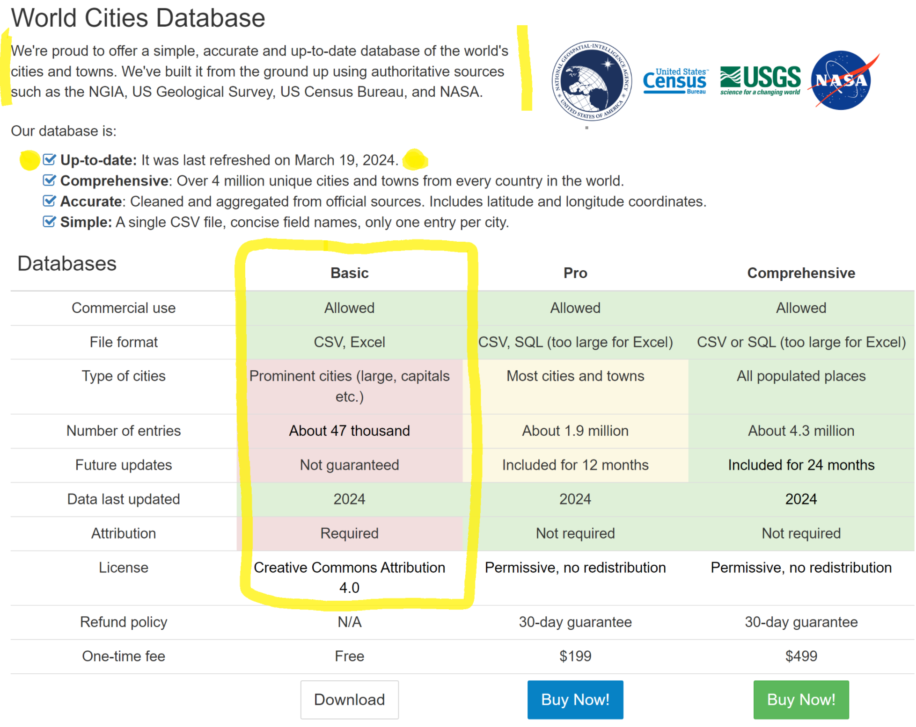

For my needs I will use BASIC database which cover 47 000 cities on the planet indicated by dots at the image below taken form their website:

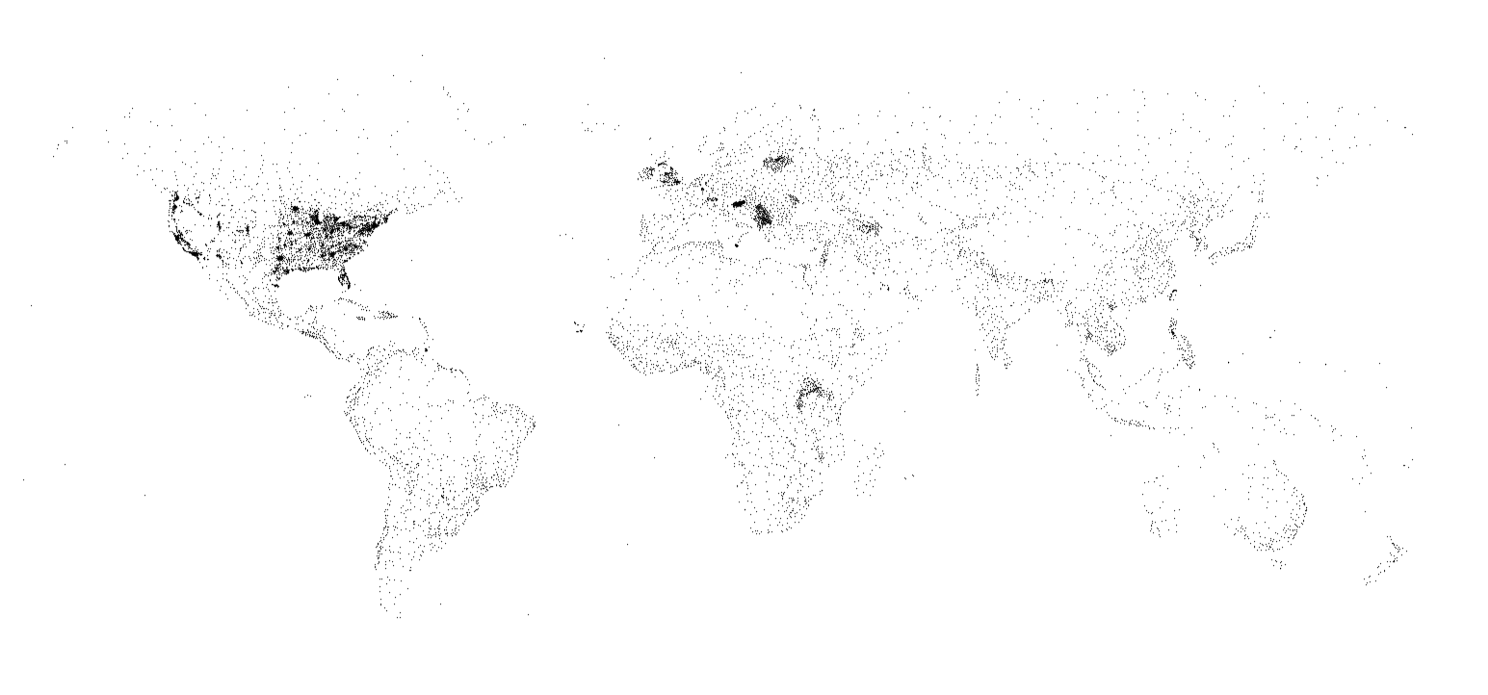
The data seem to be updated on March 19, 2024.

The license under which the data is released is Creative Commons Attribution 4.0, that means according to https://creativecommons.org/licenses/by/4.0/deed.en tht:
“You are free to:
- Share — copy and redistribute the material in any medium or format for any purpose, even commercially.
- Adapt — remix, transform, and build upon the material for any purpose, even commercially.
- The licensor cannot revoke these freedoms as long as you follow the license terms.
Under the following terms:
- Attribution — You must give appropriate credit , provide a link to the license, and indicate if changes were made . You may do so in any reasonable manner, but not in any way that suggests the licensor endorses you or your use.
- No additional restrictions — You may not apply legal terms or technological measures that legally restrict others from doing anything the license permits. “

This data seems to be reliable, since this is the product the company sells, so it may be expected that they invest resources to keep the database current and accurate.

and one supplementary:
https://en.wikipedia.org/wiki/ISO_3166-2
Is the Wikipedia list of countries
- https://worldpopulationreview.com/country-rankings/transcontinental-countries
From this website I downloaded the csv file containing countries that extend to more then one continent. This data required normalizarion up to Third Normal Form which I did using Jupyter Notebook.

The information about the website indicates that this is for profit organization:
WorldPopulationReview.com is an independent for-profit organization committed to delivering up-to-date global population data and demographics. Our dedicated team of nine professionals spans the globe, each bringing unique expertise and perspectives to our work. (...)
Also the Terms of use seem to be custom made for this specific website Terms | World Population Review
There is long list of restricion on the use of the data and also No warranties section stating that:
This Website is provided “as is,” with all faults, and World Population Review makes no express or implied representations or warranties, of any kind related to this Website or the materials contained on this Website.
I only need this data to find how counries relate to the continents, and so thisi is not of critical importance.

1.104 (Quality, level of detail, documentation, interrelation, use, discoverability) and assess the terms of use (as in discussion 1.206)

===========
1.104
Data set assesment:
- • Quality: Is the data reliable? On what basis do you make that judgement?
- • Detail: How much detail is there? Is the information helpful?
- • Documentation: How clear is it what the data means? Where was the documentation? Was it easy to find?
- • Interrelation: Would it be useful to connect to other data sets? Which? How easy would that be?
- • Use: What could you use it for? What questions would you like to ask the dataset but can't? What's missing?
- • Discoverability: How easy was it to find open data in your chosen domain? Where did you go? Were there many alternatives?

1.206 Exploring terms of use and licenses on publicly-available data (discussion prompt)
Consider the data source you discussed earlier (in Discussion Prompt 1.104). Find any explicit license, ownership and terms of use statements made about the data. Bear in mind that these may be in multiple places, and they may not be entirely consistent.
Discuss:
• What have you found?
• Where did you find the information?
• What is not allowed by the terms of the license? Does this restrict use in any significant way?
• How easy is it for the licensing and rights information to get separated from the data?

Stage 1. Find and critique a dataset

1. Choose a source of open data.
1. Dataset is appropriate (5%)– the data should be open, real (not artificial) and not too simple. It should fit the theme.
2. Dataset assessment (5%)– all criteria should be addressed
3. Interest in the dataset (5%)– should be clear and well justified
4. Research questions (5%) – questions are identified and justify a database approach (rather than either just sorting a spreadsheet or, on the other hand, using a statistical or machine learning approach)

This can be one that you've used earlier in this module, or it can be a new source.
You may also combine two simpler datasets, provided there is benefit in linking them.

The data must be open and real (not generated artificially for learning or research), and a normalised, relational model for the data can't have been published already.

1. Dataset is appropriate (5%)– the data should be open, real (not artificial) and not too simple. It should fit the theme.

Finding appropriate data was diffficult. Most of the data I was able to find was of type 1NF. That is why I decided to combine three diferent datasets.

Correcting manually runways.csv data
524981,524977,"AGLM",3477,98,"GVL",0,0,"10",-10.29597,16632257,37,100,98,"28",-10.29753,166.33184,39,280,98
524981,524977,"AGLM",3477,98,"GVL",0,0,"10",-10.29597,166.32257,37,100,98,"28",-10.29753,166.33184,39,280,98

520686,30298,"LIDV",3855,265,"GRS",0,0,"10",44.7917,116686,,109,1010,"28",44.7894,11.6781,,289,213
520686,30298,"LIDV",3855,265,"GRS",0,0,"10",44.7917,116.686,,109,1010,"28",44.7894,11.6781,,289,213

Spoted anomaly in the data – county did not match region codebase
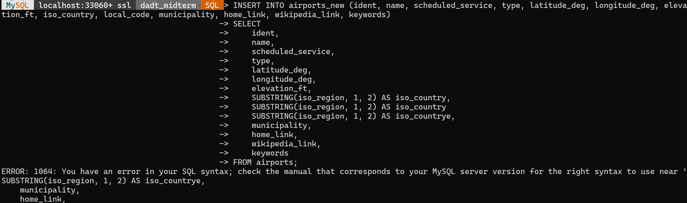

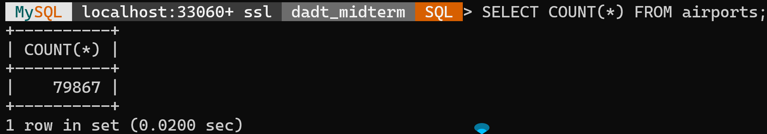
SELECT COUNT(*) FROM airports;

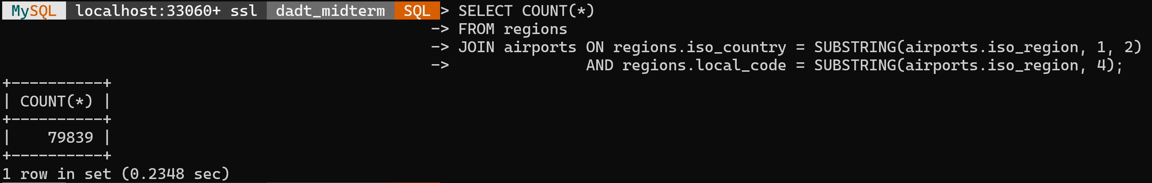
SELECT COUNT(*)
FROM regions
JOIN airports ON regions.iso_country = SUBSTRING(airports.iso_region, 1, 2)
AND regions.local_code = SUBSTRING(airports.iso_region, 4);

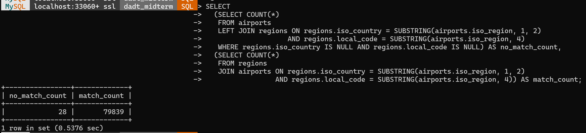
SELECT
(SELECT COUNT(*)
FROM airports
LEFT JOIN regions ON regions.iso_country = SUBSTRING(airports.iso_region, 1, 2)
AND regions.local_code = SUBSTRING(airports.iso_region, 4)
WHERE regions.iso_country IS NULL AND regions.local_code IS NULL) AS no_match_count,
(SELECT COUNT(*)
FROM regions
JOIN airports ON regions.iso_country = SUBSTRING(airports.iso_region, 1, 2)
AND regions.local_code = SUBSTRING(airports.iso_region, 4)) AS match_count;

Identified the airports which generated problem
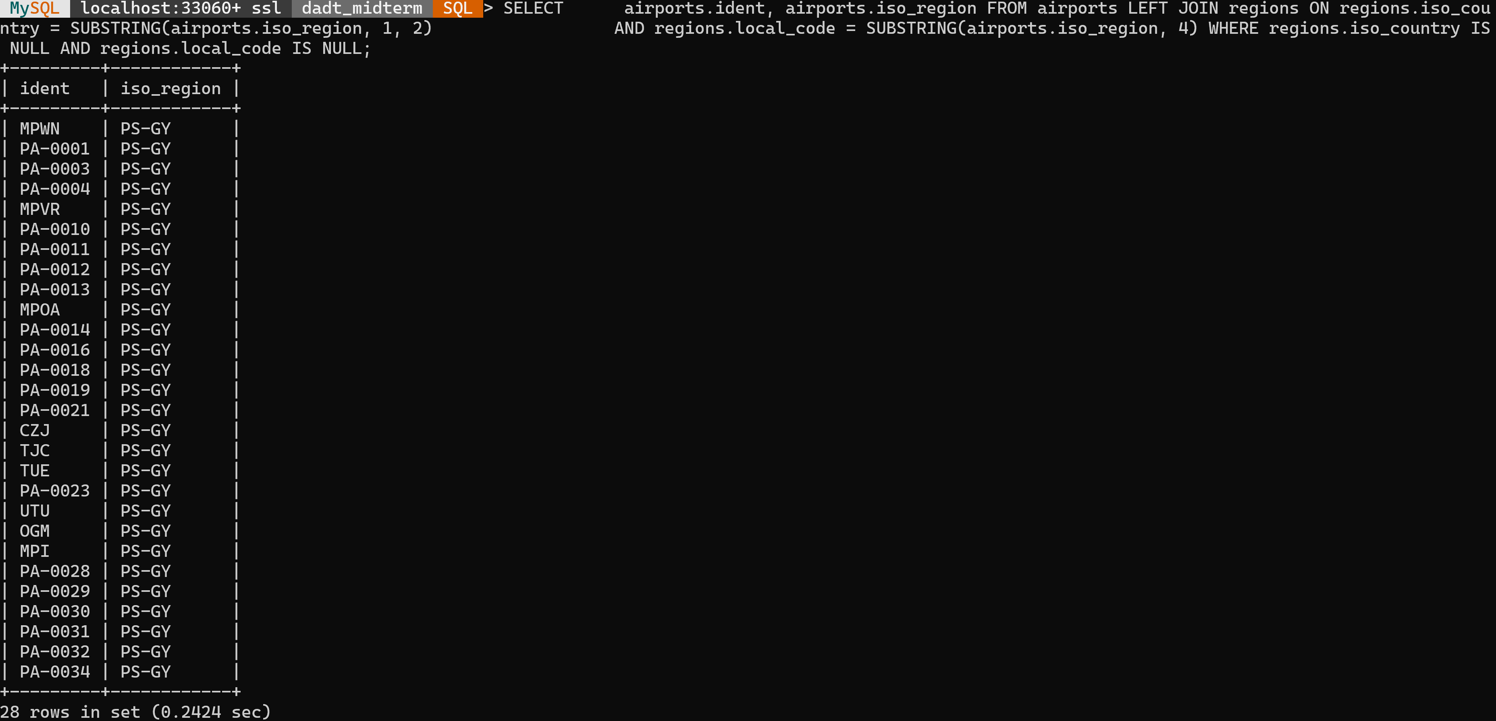
SELECT airports.ident, airports.iso_region FROM airports LEFT JOIN regions ON regions.iso_country = SUBSTRING(airports.iso_region, 1, 2) AND regions.local_code = SUBSTRING(airports.iso_region, 4) WHERE regions.iso_country IS NULL AND regions.local_code IS NULL;

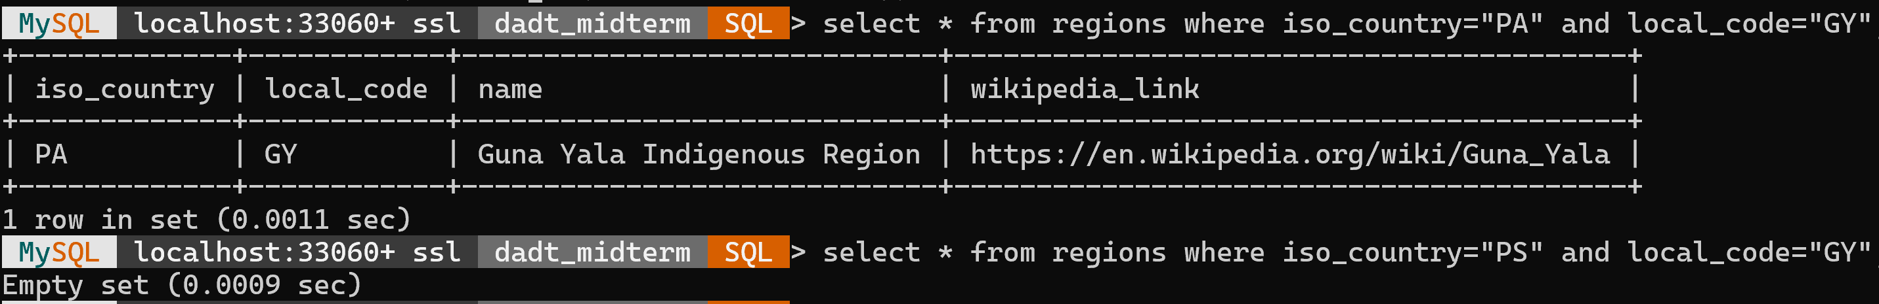
select * from regions where iso_country="PA" and local_code="GY";
.select * from regions where iso_country="PS" and local_code="GY";

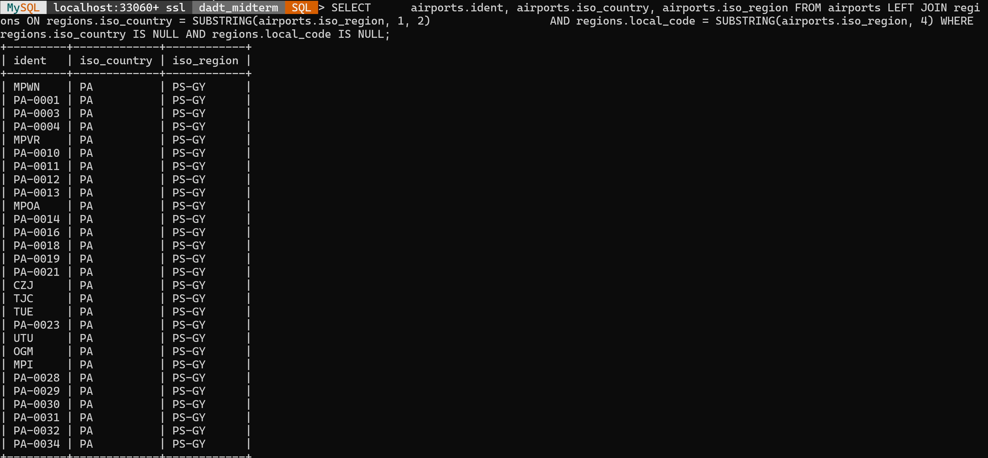
SELECT airports.ident, airports.iso_country, airports.iso_region
FROM airports LEFT JOIN regions ON regions.iso_country = SUBSTRING(airports.iso_region, 1, 2)
AND regions.local_code = SUBSTRING(airports.iso_region, 4)
WHERE regions.iso_country IS NULL AND regions.local_code IS NULL;

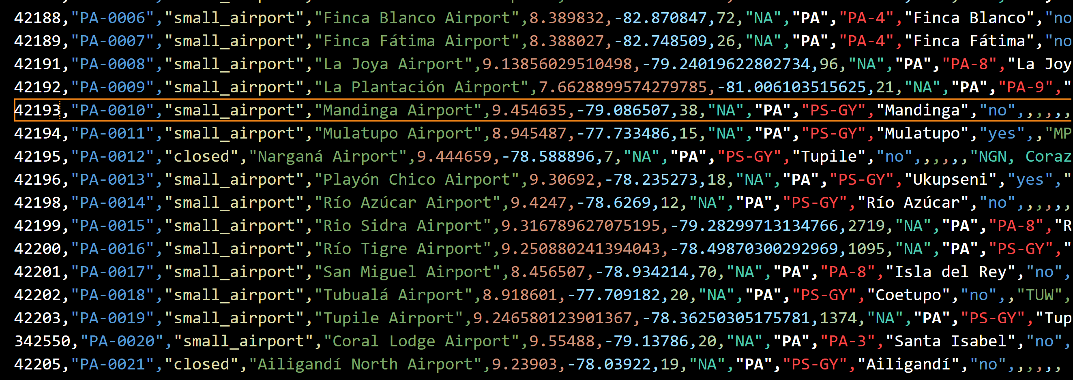
42193,"PA-0010","small_airport","Mandinga Airport",9.454635,-79.086507,38,"NA","PA","PS-GY","Mandinga","no",,,,,,
42194,"PA-0011","small_airport","Mulatupo Airport",8.945487,-77.733486,15,"NA","PA","PS-GY","Mulatupo","yes",,"MPP",,,"https://en.wikipedia.org/wiki/Mulatupo_Airport",
42195,"PA-0012","closed","Narganá Airport",9.444659,-78.588896,7,"NA","PA","PS-GY","Tupile","no",,,,,,"NGN, Corazón de Jesús"
42196,"PA-0013","small_airport","Playón Chico Airport",9.30692,-78.235273,18,"NA","PA","PS-GY","Ukupseni","yes","MPPH","PYC",,,"https://en.wikipedia.org/wiki/Play%C3%B3n_Chico_Airport",
42198,"PA-0014","small_airport","Río Azúcar Airport",9.4247,-78.6269,12,"NA","PA","PS-GY","Río Azúcar","no",,,,,,
42199,"PA-0015","small_airport","Rio Sidra Airport",9.316789627075195,-79.28299713134766,2719,"NA","PA","PA-8","Rio Sidra","no",,,,,,
42200,"PA-0016","small_airport","Río Tigre Airport",9.250880241394043,-78.49870300292969,1095,"NA","PA","PS-GY","Río Tigre","no",,,,,,

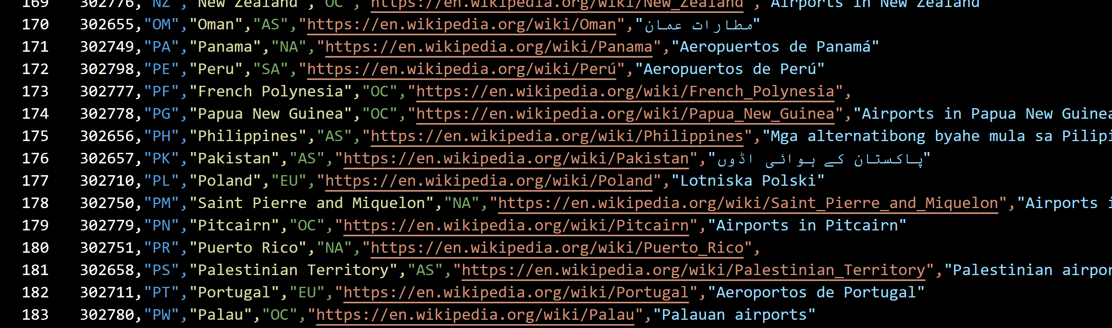

PA is Panama and PS is Palestinian territory 33

errors in cities
While i wanted to assignbe a foreign key on iso2 field to use codes only in countries table i encountered a problem when trying to assign the key.
ALTER TABLE cities
ADD CONSTRAINT fk_city_to_country_code
FOREIGN KEY (iso2) REFERENCES countries(code);

I dentified the nonexistent codes using this commanf:
SELECT iso2, COUNT(*) as city_count
FROM cities
WHERE iso2 NOT IN (SELECT code FROM countries)
GROUP BY iso2;

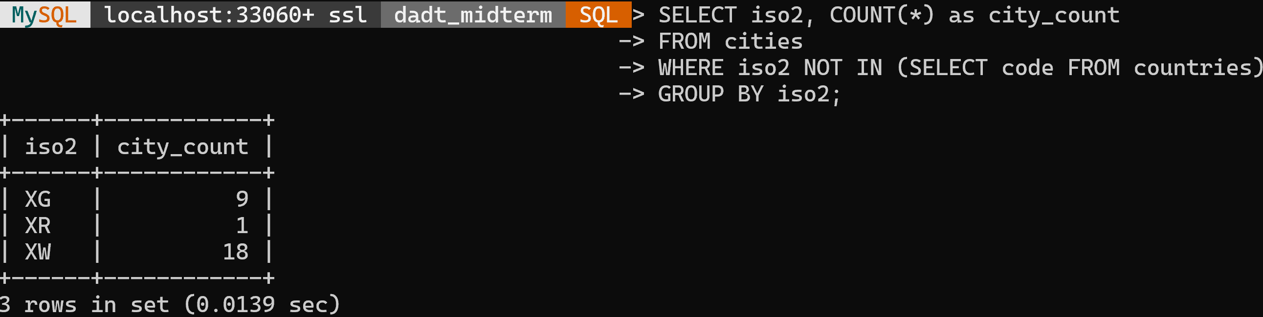
those codes are related the following cities
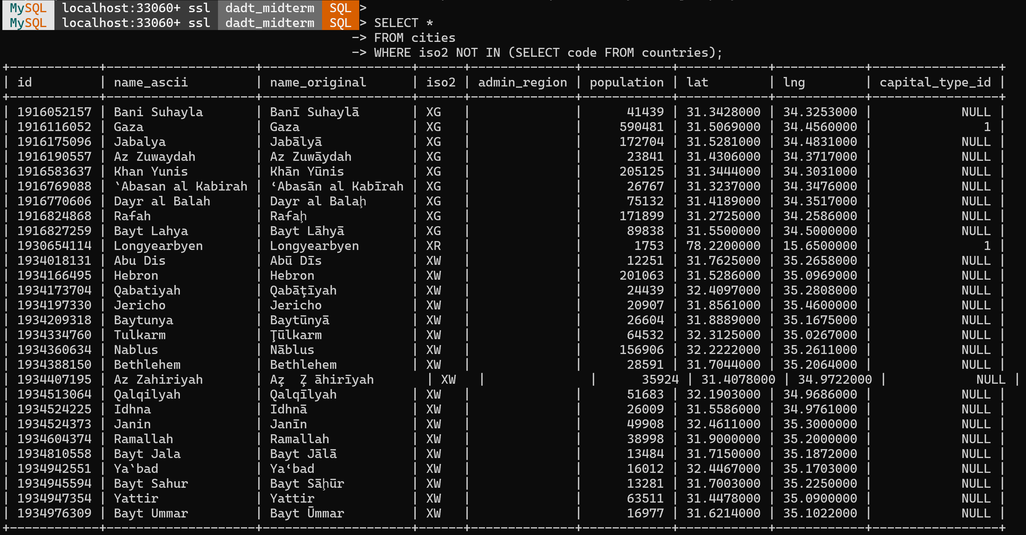

By inwestigating wikiedia it turns out that those codes are not valid, Acco9rfig to https://en.wikipedia.org/wiki/ISO_3166-1_alpha-2
thosw are free for assignment at the disposal of users:

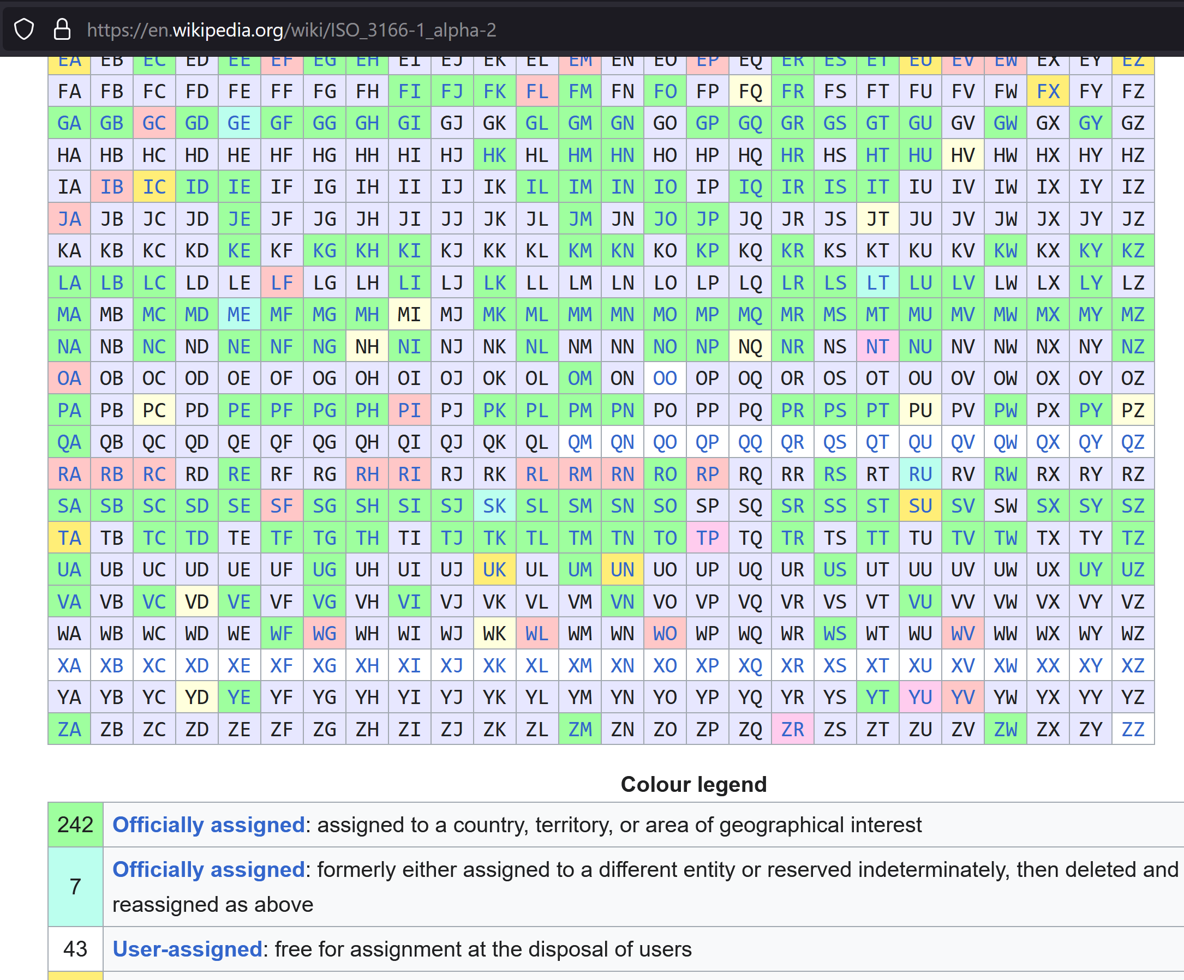 Based on this i decided to replace those codes by NULL in the iso2 field

UPDATE cities SET iso2 = NULL WHERE iso2 NOT IN (SELECT code FROM countries);

now assigning a foreign key was successful;
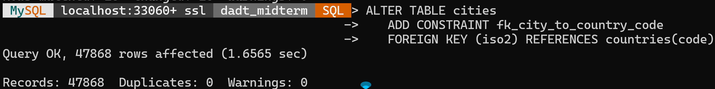

very long command to complete:
With more then 40000 rows in cities table and 4000 in admin_regions this join operation took 10 minutes to complete;
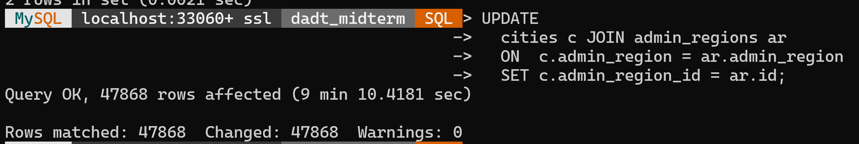

4. Research questions (5%) – questions are identified and justify a database approach (rather than either just sorting a spreadsheet or, on the other hand, using a statistical or machine learning approach)
Think about research questions related to datasets

2. Assess the dataset in your report. You should use the criteria used in discussion
2. Dataset assessment (5%)– all criteria should be addressed

3. Explain your interest in your report. Why is this an interesting dataset?
Give some questions you would like to ask of the dataset that a database application could help wi

3. Interest in the dataset (5%)– should be clear and well justified

4. Research questions
Research questions (5%) – questions are identified and justify a database approach (rather than either just sorting a spreadsheet or, on the other hand, using a statistical or machine learning approach)

Stage 2. Model your data

NOTE:
When you draw your E/R diagram, follow the rules from this module and its set reading. Lots of other things get
called E/R diagrams (you may have met other ones for other modules). Only diagrams that match the ones in this
module will get full credit.

1. Draw a complete E/R model of the data.
If you are only implementing a subset of the data structure, justify your decision in the report. All diagrams must be in the report pdf.
1. E/R model (5%) – identifies all fields and entities to be modelled

2. Add cardinality to your E/R diagram.
If there are any structures that are not compatible with the Relational model, draw a second diagram showing
the modified structure.

2. E/R diagram (5%) – diagram is clear, legal and uses ellipse/rhombus/rectangle notation

airports.csv:
- "id",
- "ident",
- "type",
- "name",
- "latitude_deg",
- "longitude_deg",
- "elevation_ft",
- "continent",
- "iso_country",
- "iso_region",
- "municipality",
- "scheduled_service",
- "gps_code",
- "iata_code",
- "local_code",
- "home_link",
- "wikipedia_link",
- "keywords"

transcontinental-countries-2024.csv
- "country",
- "TranscontinentalCountriesContiguous",
- "TranscontinentalCountriesNonContiguous",
- "TranscontinentalCountriesDebatable",
- "TranscontinentalCountriesContinentsTouched",
- "TranscontinentalCountriesAdditionalDetails"

runways.csv
- "id",
- "airport_ref",
- "airport_ident",
- "length_ft",
- "width_ft",
- "surface",
- "lighted",
- "closed",
- "le_ident",
- "le_latitude_deg",
- "le_longitude_deg",
- "le_elevation_ft",
- "le_heading_degT",
- "le_displaced_threshold_ft",
- "he_ident",
- "he_latitude_deg",
- "he_longitude_deg",
- "he_elevation_ft",
- "he_heading_degT",
- "he_displaced_threshold_ft"

worldcities.csv
- "city",
- "city_ascii",
- "lat","lng",
- "country",
- "iso2",
- "iso3",
- "admin_name",
- "capital",
- "population",
- "id"

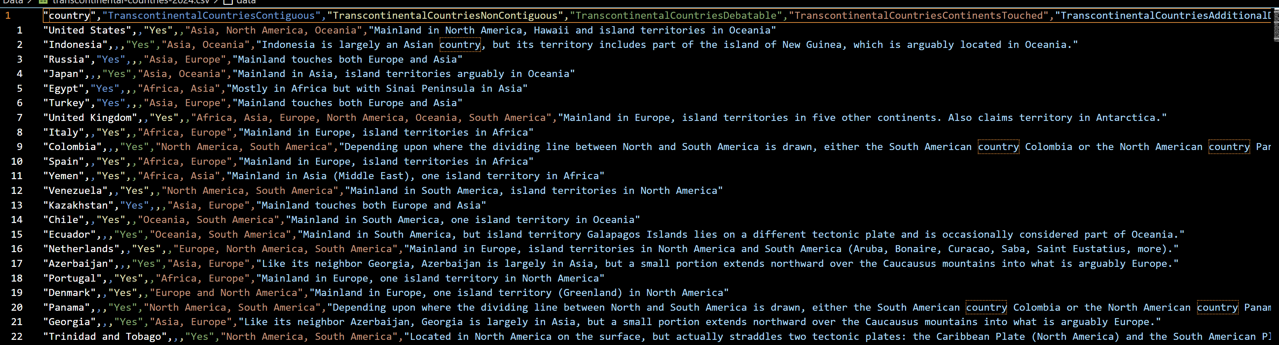

0NF
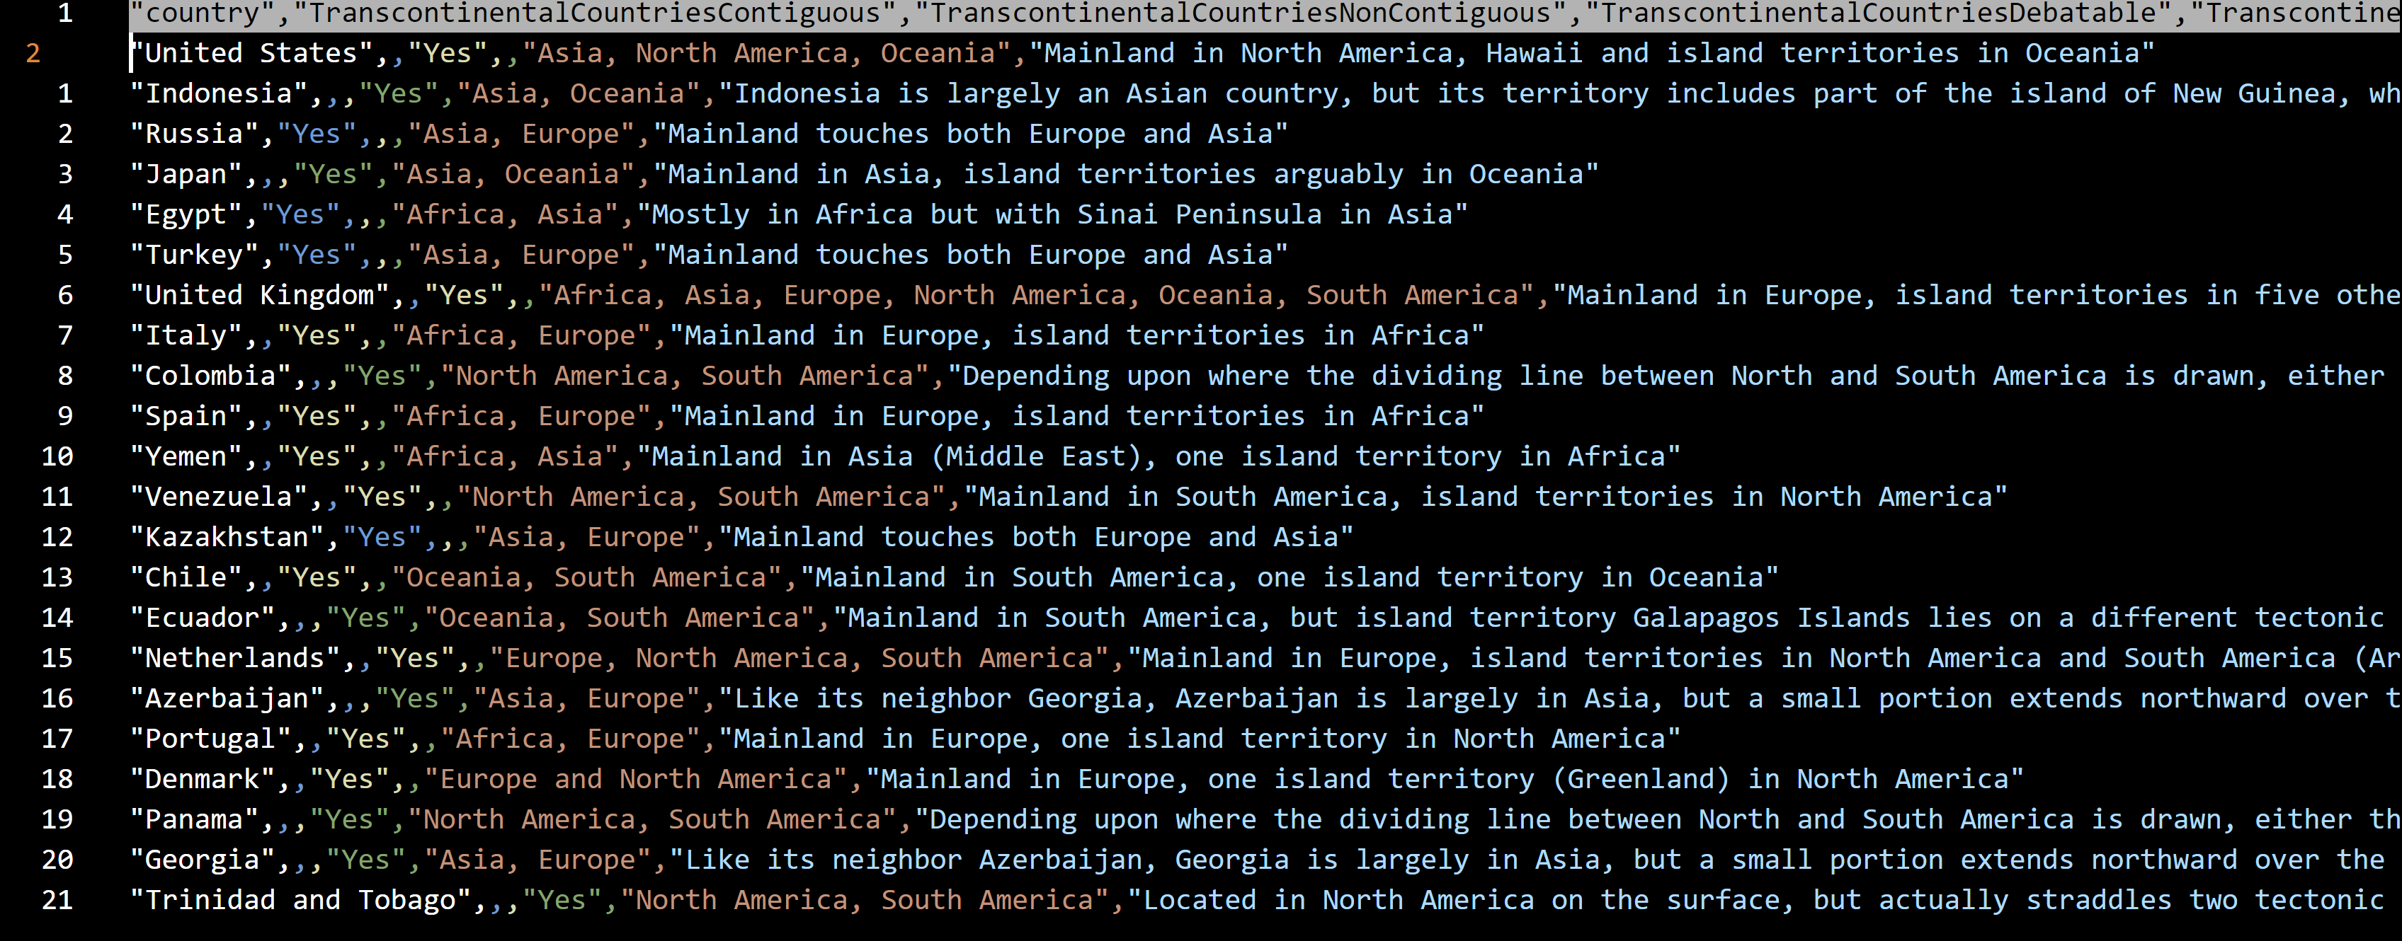

I had simplified the fields name :
"country","contiguous","contiguous","debatable","continentsTouched","additionalDetails"

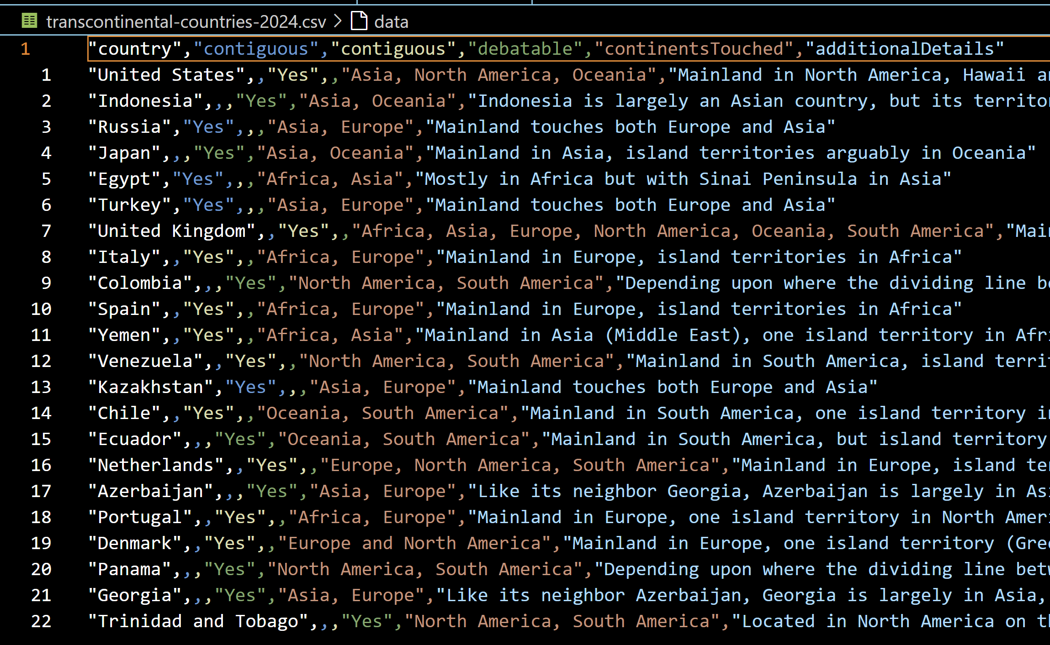
The table is not normalized yet. There is not a primary key selected and field “continentsTouched” contains list of continetns instead just one.
To make this 1NF I need to split this into new rows.

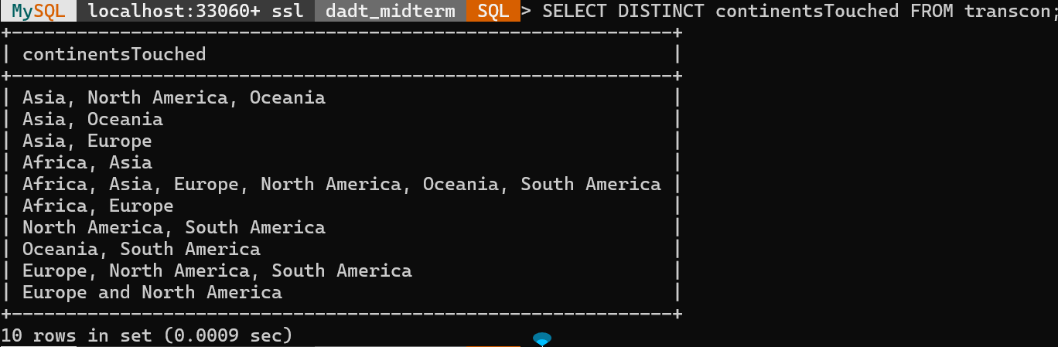

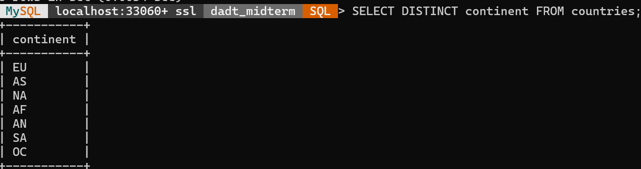

3. List database tables and fields.
Evaluate the tables against the normal forms and adjust to ensure that your database will be at least in 3NF. Include an evaluation of which normal forms your database is in. If it isn't in higher forms, such as BCNF or 4NF, justify your decision not to normalise further.

3. E/R to relational mapping (5%) – modelling is clear and sensible; issues with the relational model are resolved

4. Relational model normalisation (5%) – analysis is clear, explicit and accurate,
resulting in an appropriate normalisatio

Stage 3. Create the database
1. Accurately implement the model (5%) – the MySQL database reflects the models
2. Implementation is sensible (5%) – including column types, primary and foreign keys, and other constraints
3. Critical reflection (5%) – issues with data and implementation are noted, along with how well these relate to interest and research questions
4. Queries – queries are correct and accurately reflect the identified questions

1. Build the database structure in MySQL in the lab environment.
Record all CREATE commands used in your report.

2. Enter instance data.
This can be a usable sample of the dataset or all the dataset.
Detail how you added the data in your report.

3. Reflect on how well the database reflects the data.
In your report note one or two points of elements that do or don't work well.

4. List SQL commands that answer questions identified in Stage 1/Step 3.
If any can't be answered, explain why.

Stage 4. Create a simple web application
1. Application runs (5%)
2. Database interaction works (5%) – Connections and queries are appropriately handled
3. Application works (5%) – Data is presented appropriately; valid and accessible HTML
4. Goals are satisfied (5%) – Motivation and (some) queries are addressed

1. Write a node.js module to present a web application that queries the database.
This can be quite simple, but should address some of the motivation and questions identified in Stage 1/Step 3. The user account used to connect should have appropriate privileges.

2. Take screenshots of the main screens from your web application and include them in yo.ur report.

Extra stage
Clear referencing (5%)
1. Referencing includes data, literature and code labelling (5%)– All external sources of data, code, techniques and research are clearly included in the report (5 marks)
Discretionary extra credit (15%)

Referenc]es
https://stackoverflow.com/questions/32737478/how-should-i-resolve-secure-file-priv-in-mysql
-- used to see where is the secure folder for the database- in LAB envrioment it is set to empty. In windows it is more complicated path
+------------------+------------------------------------------------+
| Variable_name | Value |
+------------------+------------------------------------------------+
| secure_file_priv | C:\ProgramData\MySQL\MySQL Server 8.0\Uploads\ |
+------------------+------------------------------------------------+

SHOW VARIABLES LIKE 'secure_file_priv';

https://stackoverflow.com/questions/14127529/import-data-in-mysql-from-a-csv-file-using-load-data-infile
https://dev.mysql.com/doc/refman/8.0/en/load-data.html

commands – LAB

-- ========== CREATING DATABASE ===========
Drop database dadt_midterm; # FOR DEVELOPMENT ONLY!!!!

show DATABASES;
CREATE DATABASE dadt_midterm;

USE dadt_midterm;

-- ========== CITIES =======
CREATE TABLE cities (
city VARCHAR(255),
city_ascii VARCHAR(255),
lat DECIMAL(8, 5),
lng DECIMAL(8, 5),
country VARCHAR(255),
iso2 CHAR(2),
iso3 CHAR(3),
admin_name VARCHAR(255),
capital VARCHAR(255),
population INT,
id INT PRIMARY KEY);

DESCRIBE cities;

LOAD DATA INFILE 'Project/Data/worldcities.csv'
-- LOAD DATA INFILE 'Project/Data/worldcities.csv'
INTO TABLE cities
FIELDS TERMINATED BY ',' ENCLOSED BY '"'
LINES TERMINATED BY '\r\n'
IGNORE 1 LINES
(city, city_ascii, lat, lng, country, iso2, iso3, admin_name, capital, @population, id)
SET population = NULLIF(@population, '');

-- ====== AIRPORTS ======
CREATE TABLE airports (
id INT PRIMARY KEY,
ident VARCHAR(7),
type VARCHAR(25),
name VARCHAR(255),
latitude_deg DECIMAL(8, 5),
longitude_deg DECIMAL(8, 5),
elevation_ft INT,
continent CHAR(2),
iso_country CHAR(2),
iso_region VARCHAR(10),
municipality VARCHAR(255),
scheduled_service TINYINT,
gps_code VARCHAR(10),
iata_code VARCHAR(10),
local_code VARCHAR(10),
home_link VARCHAR(255),
wikipedia_link VARCHAR(255),
keywords VARCHAR(512)
);

LOAD DATA INFILE 'Project/Data/airports.csv'
-- LOAD DATA INFILE 'Project/Data/airports.csv'

INTO TABLE airports
FIELDS TERMINATED BY ','
OPTIONALLY ENCLOSED BY '"'
LINES TERMINATED BY '\n'
IGNORE 1 LINES
(id, ident, type, name, latitude_deg, longitude_deg, @elevation_ft, continent, iso_country, iso_region, municipality, @scheduled_service, gps_code, iata_code, local_code, home_link, wikipedia_link, keywords)
SET elevation_ft = NULLIF(@elevation_ft, ''),
scheduled_service = CASE
WHEN @scheduled_service = 'yes' THEN 1
WHEN @scheduled_service = 'no' THEN 0
ELSE NULL
END;

-- ======= COUNTRIES ========
CREATE TABLE countries (
id INT,
code CHAR(2) PRIMARY KEY,
name VARCHAR(100),
continent CHAR(2),
wikipedia_link VARCHAR(255),
keywords VARCHAR(512)
);
LOAD DATA INFILE 'Project/Data/countries.csv'
-- LOAD DATA INFILE 'Project/Data/countries.csv'
INTO TABLE countries
FIELDS TERMINATED BY ','
OPTIONALLY ENCLOSED BY '"'
LINES TERMINATED BY '\n'
IGNORE 1 LINES;

-- ======== REGIONS ==========
CREATE TABLE regions (
id INT,
code VARCHAR(7) PRIMARY KEY,
local_code VARCHAR(5),
name VARCHAR(100),
continent CHAR(2),
iso_country CHAR(2),
wikipedia_link VARCHAR(255),
keywords VARCHAR(512),
FOREIGN KEY (iso_country) REFERENCES countries(code)
);

LOAD DATA INFILE 'Project/Data/regions.csv'
-- LOAD DATA INFILE 'Project/Data/regions.csv'
INTO TABLE regions
FIELDS TERMINATED BY ','
OPTIONALLY ENCLOSED BY '"'
LINES TERMINATED BY '\n'
IGNORE 1 LINES;

-- ======== RUNWAYS =======
CREATE TABLE runways (
id INT PRIMARY KEY,
airport_ref INT,
airport_ident VARCHAR(10),
length_ft INT UNSIGNED,
width_ft INT UNSIGNED,
surface VARCHAR(255),
lighted TINYINT,
closed TINYINT,
le_ident VARCHAR(10),
le_latitude_deg DECIMAL(8, 5),
le_longitude_deg DECIMAL(8, 5),
le_elevation_ft INT,
le_heading_degT INT,
le_displaced_threshold_ft INT,
he_ident VARCHAR(10),
he_latitude_deg DECIMAL(8, 5),
he_longitude_deg DECIMAL(8, 5),
he_elevation_ft INT,
he_heading_degT INT,
he_displaced_threshold_ft INT
);

LOAD DATA INFILE 'Project/Data/runways.csv'
-- LOAD DATA INFILE 'Project/Data/runways.csv'
INTO TABLE runways
FIELDS TERMINATED BY ','
OPTIONALLY ENCLOSED BY '"'
LINES TERMINATED BY '\n'
IGNORE 1 LINES
(
id,
airport_ref,
airport_ident,
@length_ft,
@width_ft,
@surface,
@lighted,
@closed,
@le_ident,
@le_latitude_deg,
@le_longitude_deg,
@le_elevation_ft,
@le_heading_degT,
@le_displaced_threshold_ft,
@he_ident,
@he_latitude_deg,
@he_longitude_deg,
@he_elevation_ft,
@he_heading_degT,
@he_displaced_threshold_ft
)
SET
length_ft = NULLIF(@length_ft, ''),
width_ft = NULLIF(@width_ft, ''),
surface = NULLIF(@surface, ''),
lighted = NULLIF(@lighted, ''),
closed = NULLIF(@closed, ''),
le_ident = NULLIF(@le_ident, ''),
le_latitude_deg = NULLIF(@le_latitude_deg, ''),
le_longitude_deg = NULLIF(@le_longitude_deg, ''),
le_elevation_ft = NULLIF(@le_elevation_ft, ''),
le_heading_degT = NULLIF(@le_heading_degT, ''),
le_displaced_threshold_ft = NULLIF(@le_displaced_threshold_ft, ''),
he_ident = NULLIF(@he_ident, ''),
he_latitude_deg = NULLIF(@he_latitude_deg, ''),
he_longitude_deg = NULLIF(@he_longitude_deg, ''),
he_elevation_ft = NULLIF(@he_elevation_ft, ''),
he_heading_degT = NULLIF(@he_heading_degT, ''),
he_displaced_threshold_ft = NULLIF(@he_displaced_threshold_ft, '')
;

-- ===== TRANSCONTINENTAL COUNTRIES ======
CREATE TABLE transcon (
country VARCHAR(100),
contiguous VARCHAR(10),
nonContiguous VARCHAR(10),
debatable VARCHAR(10),
continentsTouched VARCHAR(255),
additionalDetails TEXT
);

LOAD DATA INFILE 'Project/Data/transcontinental-countries-2024.csv'
-- LOAD DATA INFILE 'Project/Data/transcontinental-countries-2024.csv'
INTO TABLE transcon
FIELDS TERMINATED BY ','
OPTIONALLY ENCLOSED BY '"'
LINES TERMINATED BY '\n'
IGNORE 1 LINES
(
country,
contiguous,
nonContiguous,
debatable,
continentsTouched,
additionalDetails
);

-- ======= CONTINENTS ========
-- ==== getting continents shortcuts and name to create continents relation
SELECT DISTINCT continent FROM countries;
SELECT DISTINCT continentsTouched FROM transcon;

-- ==== creating continents vs code
CREATE TABLE continents (
code CHAR(2) PRIMARY KEY,
name VARCHAR(100)
);

INSERT INTO continents (code, name)
VALUES
('AF', 'Africa'),
('AS', 'Asia'),
('EU', 'Europe'),
('NA', 'North America'),
('OC', 'Oceania'),
('SA', 'South America'),
('AN', 'Antarctica')
;

-- ====== splitting transcon into two tables to in 2NF --- done in pandas

-- ==== TOUCHED1TOUCH ======
CREATE TABLE touched1touch (
country_code CHAR(2),
continent_name VARCHAR(100),
PRIMARY KEY (country_code, continent_name)
);

LOAD DATA INFILE 'Project/Data/transcon_r1.csv'
-- LOAD DATA INFILE 'Project/Data/transcon_r1.csv'
INTO TABLE touched1touch
FIELDS TERMINATED BY ','
ENCLOSED BY '"'
LINES TERMINATED BY '\n'
IGNORE 1 LINES
(country_code, continent_name);

-- ====== TOUCHED2DET ========
CREATE TABLE touched2det (
country_code CHAR(2) PRIMARY KEY,
contiguous TINYINT,
nonContiguous TINYINT,
debatable TINYINT,
additionalDetails TEXT
);

LOAD DATA INFILE 'Project/Data/transcon_r2.csv'
-- LOAD DATA INFILE 'Project/Data/transcon_r2.csv'
INTO TABLE touched2det
FIELDS TERMINATED BY ','
OPTIONALLY ENCLOSED BY '"'
LINES TERMINATED BY '\r\n'
IGNORE 1 LINES
(country_code, contiguous, nonContiguous, debatable, additionalDetails);

commands

commands

\connect root@localhost
\sql

-- ========== CREATING DATABASE ===========
Drop database dadt_midterm; # FOR DEVELOPMENT ONLY!!!!

show DATABASES;
CREATE DATABASE dadt_midterm;

USE dadt_midterm;

-- ========== CITIES =======
CREATE TABLE cities (
city VARCHAR(255),
city_ascii VARCHAR(255),
lat DECIMAL(8, 5),
lng DECIMAL(8, 5),
country VARCHAR(255),
iso2 CHAR(2),
iso3 CHAR(3),
admin_name VARCHAR(255),
capital VARCHAR(255),
population INT,
id INT PRIMARY KEY);

DESCRIBE cities;

LOAD DATA INFILE 'C:\\ProgramData\\MySQL\\MySQL Server 8.0\\Uploads\\worldcities.csv'
-- LOAD DATA INFILE 'Project/Data/worldcities.csv'
INTO TABLE cities
FIELDS TERMINATED BY ',' ENCLOSED BY '"'
LINES TERMINATED BY '\r\n'
IGNORE 1 LINES
(city, city_ascii, lat, lng, country, iso2, iso3, admin_name, capital, @population, id)
SET population = NULLIF(@population, '');

-- ====== AIRPORTS ======
CREATE TABLE airports (
id INT PRIMARY KEY,
ident VARCHAR(7),
type VARCHAR(25),
name VARCHAR(255),
latitude_deg DECIMAL(8, 5),
longitude_deg DECIMAL(8, 5),
elevation_ft INT,
continent CHAR(2),
iso_country CHAR(2),
iso_region VARCHAR(10),
municipality VARCHAR(255),
scheduled_service TINYINT,
gps_code VARCHAR(10),
iata_code VARCHAR(10),
local_code VARCHAR(10),
home_link VARCHAR(255),
wikipedia_link VARCHAR(255),
keywords VARCHAR(512)
);

LOAD DATA INFILE 'C:\\ProgramData\\MySQL\\MySQL Server 8.0\\Uploads\\airports.csv'
-- LOAD DATA INFILE 'Project/Data/airports.csv'

INTO TABLE airports
FIELDS TERMINATED BY ','
OPTIONALLY ENCLOSED BY '"'
LINES TERMINATED BY '\n'
IGNORE 1 LINES
(id, ident, type, name, latitude_deg, longitude_deg, @elevation_ft, continent, iso_country, iso_region, municipality, @scheduled_service, gps_code, iata_code, local_code, home_link, wikipedia_link, keywords)
SET elevation_ft = NULLIF(@elevation_ft, ''),
scheduled_service = CASE
WHEN @scheduled_service = 'yes' THEN 1
WHEN @scheduled_service = 'no' THEN 0
ELSE NULL
END;

-- ======= COUNTRIES ========
CREATE TABLE countries (
id INT,
code CHAR(2) PRIMARY KEY,
name VARCHAR(100),
continent CHAR(2),
wikipedia_link VARCHAR(255),
keywords VARCHAR(512)
);
LOAD DATA INFILE 'C:\\ProgramData\\MySQL\\MySQL Server 8.0\\Uploads\\countries.csv'
-- LOAD DATA INFILE 'Project/Data/countries.csv'
INTO TABLE countries
FIELDS TERMINATED BY ','
OPTIONALLY ENCLOSED BY '"'
LINES TERMINATED BY '\n'
IGNORE 1 LINES;

-- ======== REGIONS ==========
CREATE TABLE regions (
id INT,
code VARCHAR(7) PRIMARY KEY,
local_code VARCHAR(5),
name VARCHAR(100),
continent CHAR(2),
iso_country CHAR(2),
wikipedia_link VARCHAR(255),
keywords VARCHAR(512),
FOREIGN KEY (iso_country) REFERENCES countries(code)
);

LOAD DATA INFILE 'C:\\ProgramData\\MySQL\\MySQL Server 8.0\\Uploads\\regions.csv'
-- LOAD DATA INFILE 'Project/Data/regions.csv'
INTO TABLE regions
FIELDS TERMINATED BY ','
OPTIONALLY ENCLOSED BY '"'
LINES TERMINATED BY '\n'
IGNORE 1 LINES;

-- ======== RUNWAYS =======
CREATE TABLE runways (
id INT PRIMARY KEY,
airport_ref INT,
airport_ident VARCHAR(10),
length_ft INT UNSIGNED,
width_ft INT UNSIGNED,
surface VARCHAR(255),
lighted TINYINT,
closed TINYINT,
le_ident VARCHAR(10),
le_latitude_deg DECIMAL(8, 5),
le_longitude_deg DECIMAL(8, 5),
le_elevation_ft INT,
le_heading_degT INT,
le_displaced_threshold_ft INT,
he_ident VARCHAR(10),
he_latitude_deg DECIMAL(8, 5),
he_longitude_deg DECIMAL(8, 5),
he_elevation_ft INT,
he_heading_degT INT,
he_displaced_threshold_ft INT
);

LOAD DATA INFILE 'C:\\ProgramData\\MySQL\\MySQL Server 8.0\\Uploads\\runways.csv'
-- LOAD DATA INFILE 'Project/Data/runways.csv'
INTO TABLE runways
FIELDS TERMINATED BY ','
OPTIONALLY ENCLOSED BY '"'
LINES TERMINATED BY '\n'
IGNORE 1 LINES
(
id,
airport_ref,
airport_ident,
@length_ft,
@width_ft,
@surface,
@lighted,
@closed,
@le_ident,
@le_latitude_deg,
@le_longitude_deg,
@le_elevation_ft,
@le_heading_degT,
@le_displaced_threshold_ft,
@he_ident,
@he_latitude_deg,
@he_longitude_deg,
@he_elevation_ft,
@he_heading_degT,
@he_displaced_threshold_ft
)
SET
length_ft = NULLIF(@length_ft, ''),
width_ft = NULLIF(@width_ft, ''),
surface = NULLIF(@surface, ''),
lighted = NULLIF(@lighted, ''),
closed = NULLIF(@closed, ''),
le_ident = NULLIF(@le_ident, ''),
le_latitude_deg = NULLIF(@le_latitude_deg, ''),
le_longitude_deg = NULLIF(@le_longitude_deg, ''),
le_elevation_ft = NULLIF(@le_elevation_ft, ''),
le_heading_degT = NULLIF(@le_heading_degT, ''),
le_displaced_threshold_ft = NULLIF(@le_displaced_threshold_ft, ''),
he_ident = NULLIF(@he_ident, ''),
he_latitude_deg = NULLIF(@he_latitude_deg, ''),
he_longitude_deg = NULLIF(@he_longitude_deg, ''),
he_elevation_ft = NULLIF(@he_elevation_ft, ''),
he_heading_degT = NULLIF(@he_heading_degT, ''),
he_displaced_threshold_ft = NULLIF(@he_displaced_threshold_ft, '')
;

-- ===== TRANSCONTINENTAL COUNTRIES ======
CREATE TABLE transcon (
country VARCHAR(100),
contiguous VARCHAR(10),
nonContiguous VARCHAR(10),
debatable VARCHAR(10),
continentsTouched VARCHAR(255),
additionalDetails TEXT
);

LOAD DATA INFILE 'C:\\ProgramData\\MySQL\\MySQL Server 8.0\\Uploads\\transcontinental-countries-2024.csv'
-- LOAD DATA INFILE 'Project/Data/transcontinental-countries-2024.csv'
INTO TABLE transcon
FIELDS TERMINATED BY ','
OPTIONALLY ENCLOSED BY '"'
LINES TERMINATED BY '\n'
IGNORE 1 LINES
(
country,
contiguous,
nonContiguous,
debatable,
continentsTouched,
additionalDetails
);

-- ======= CONTINENTS ========
-- ==== getting continents shortcuts and name to create continents relation
SELECT DISTINCT continent FROM countries;
SELECT DISTINCT continentsTouched FROM transcon;

-- ==== creating continents vs code
CREATE TABLE continents (
code CHAR(2) PRIMARY KEY,
name VARCHAR(100)
);

INSERT INTO continents (code, name)
VALUES
('AF', 'Africa'),
('AS', 'Asia'),
('EU', 'Europe'),
('NA', 'North America'),
('OC', 'Oceania'),
('SA', 'South America'),
('AN', 'Antarctica')
;

-- ====== splitting transcon into two tables to in 2NF --- done in pandas

-- ==== TOUCHED1TOUCH ======
CREATE TABLE touched1touch (
country_code CHAR(2),
continent_name VARCHAR(100),
PRIMARY KEY (country_code, continent_name)
);

LOAD DATA INFILE 'C:\\ProgramData\\MySQL\\MySQL Server 8.0\\Uploads\\transcon_r1.csv'
-- LOAD DATA INFILE 'Project/Data/transcon_r1.csv'
INTO TABLE touched1touch
FIELDS TERMINATED BY ','
ENCLOSED BY '"'
LINES TERMINATED BY '\n'
IGNORE 1 LINES
(country_code, continent_name);

-- ====== TOUCHED2DET ========
CREATE TABLE touched2det (
country_code CHAR(2) PRIMARY KEY,
contiguous TINYINT,
nonContiguous TINYINT,
debatable TINYINT,
additionalDetails TEXT
);

LOAD DATA INFILE 'C:\\ProgramData\\MySQL\\MySQL Server 8.0\\Uploads\\transcon_r2.csv'
-- LOAD DATA INFILE 'Project/Data/transcon_r2.csv'
INTO TABLE touched2det
FIELDS TERMINATED BY ','
OPTIONALLY ENCLOSED BY '"'
LINES TERMINATED BY '\r\n'
IGNORE 1 LINES
(country_code, contiguous, nonContiguous, debatable, additionalDetails);

-- @@@@@@@@@@@@@@ commands2 @@@@@@@@@@@@@
CREATE TABLE regions_1nf (
iso_country CHAR(2),
local_code VARCHAR(5),
name VARCHAR(100),
wikipedia_link VARCHAR(255),
PRIMARY KEY (iso_country, local_code),
FOREIGN KEY (iso_country) REFERENCES countries(code)
);

INSERT INTO regions_1nf (iso_country, local_code, name, wikipedia_link)
SELECT iso_country, local_code, name, wikipedia_link
FROM regions;

select * from regions_1nf limit 24;

drop table regions;
SHOW TABLES;

alter table regions_1nf RENAME TO regions;
SHOW TABLES;

-- chacking if airports.ident contain NULL values. If not then it is candidate for PRIMARY KEY
SELECT count(*)
FROM airports
WHERE ident IS NULL OR ident = '';

-- ==== AIRPORTTYPES =============
-- Create list of available airport types --
SELECT DISTINCT type FROM airports;

CREATE TABLE airportTypes (
apt_type VARCHAR(25) PRIMARY KEY
);
SHOW TABLES;

INSERT INTO airportTypes (apt_type)
SELECT DISTINCT type
FROM airports;

SELECT * FROM airportTypes;

-- ====== AIRPORTS =========
-- Removing redundant data from AIRPORTS --

CREATE TABLE airports_new (
ident VARCHAR(7) PRIMARY KEY,
name VARCHAR(255),
scheduled_service TINYINT,
type VARCHAR(25),

iso_country CHAR(2),
local_code VARCHAR(5),
municipality VARCHAR(255),

latitude_deg DECIMAL(8, 5),
longitude_deg DECIMAL(8, 5),
elevation_ft INT,

home_link VARCHAR(255),
wikipedia_link VARCHAR(255),
keywords VARCHAR(512),

CONSTRAINT fk_airports__apt_type_exists__in_airporttypes FOREIGN KEY (type) REFERENCES airportTypes(apt_type),
CONSTRAINT fk_airports__iso_country_and_local_code_combination__in_regions FOREIGN KEY (iso_country, local_code) REFERENCES regions(iso_country, local_code)
);

SHOW INDEX FROM airports_new;

INSERT INTO airports_new (ident, name, scheduled_service, type, latitude_deg, longitude_deg, elevation_ft, iso_country, local_code, municipality, home_link, wikipedia_link, keywords)
SELECT
ident,
name,
scheduled_service,
type,
latitude_deg,
longitude_deg,
elevation_ft,
SUBSTRING(iso_region, 1, 2) AS iso_country,
SUBSTRING(iso_region, 4) AS local_code,
municipality,
home_link,
wikipedia_link,
keywords
FROM airports;

-- check if all data transfered;
SELECT
(SELECT COUNT(*) FROM airports) AS apts,
(SELECT COUNT(*) FROM airports_new) AS new_apts;

DROP TABLE airports;
ALTER TABLE airports_new RENAME TO airports;
SHOW TABLES;

-- SHOW ALL CONSTRAINTS AND PRIMARY KEYS -----

-- primary keys
SELECT
TABLE_NAME,
COLUMN_NAME,
CONSTRAINT_NAME
FROM
information_schema.KEY_COLUMN_USAGE
WHERE
TABLE_SCHEMA = 'dadt_midterm'
AND CONSTRAINT_NAME = 'PRIMARY';

-- constraints
SELECT
TABLE_NAME,
COLUMN_NAME,
CONSTRAINT_NAME,
REFERENCED_TABLE_NAME,
REFERENCED_COLUMN_NAME
FROM
information_schema.KEY_COLUMN_USAGE
WHERE
TABLE_SCHEMA = 'dadt_midterm'
AND REFERENCED_TABLE_NAME IS NOT NULL;

-- ======= CITIES reorganizarion =======
-- Reordering CITIES and removing redundant fields

CREATE TABLE cities_new (
id INT PRIMARY KEY,
name_ascii VARCHAR(255),
name_original VARCHAR(255),

iso2 CHAR(2),
capital VARCHAR(255),
admin_region VARCHAR(255),

population INT,
lat DECIMAL(10, 7),
lng DECIMAL(10, 7)
);

-- Populating CITIES_NEW --
INSERT INTO cities_new (
id,
name_ascii,
name_original,
iso2,
capital,
admin_region,
population,
lat,
lng
)
SELECT
id,
city_ascii AS name_ascii,
city AS name_original,
iso2,
capital,
admin_name AS admin_region,
population,
lat,
lng
FROM cities;

SELECT * FROM cities_new LIMIT 20;

DROP TABLE cities;
ALTER TABLE cities_new RENAME AS cities;

-- ===== CAPITAL TYPES ========
SELECT DISTINCT capital FROM cities;

CREATE TABLE capital_types (
id INT PRIMARY KEY,
capital VARCHAR(10)
);
-- Checking what types of captal are used--
SELECT DISTINCT capital FROM cities;

-- Populating capital type --
INSERT INTO capital_types (id, capital)
VALUES (1,'primary'),(2,'admin'),(3,'minor');

ALTER TABLE cities ADD capital_type_id INT;

UPDATE
cities JOIN capital_types
ON cities.capital = capital_types.capital
SET cities.capital_type_id = capital_types.id;

ALTER TABLE cities DROP COLUMN capital;

-- Adding constraints regrding capitals and the countries
ALTER TABLE cities
ADD CONSTRAINT fk_capital_type
FOREIGN KEY (capital_type_id) REFERENCES capital_types(id);

ALTER TABLE cities
ADD CONSTRAINT fk_city_to_country_code
FOREIGN KEY (iso2) REFERENCES countries(code);

-- error soving
SELECT iso2, COUNT(*) as city_count
FROM cities
WHERE iso2 NOT IN (SELECT code FROM countries)
GROUP BY iso2;

SELECT *
FROM cities
WHERE iso2 NOT IN (SELECT code FROM countries);

UPDATE cities SET iso2 = NULL WHERE iso2 NOT IN (SELECT code FROM countries);

-- trying again to assign the foreign key ---

ALTER TABLE cities
ADD CONSTRAINT fk_city_to_country_code
FOREIGN KEY (iso2) REFERENCES countries(code);

-- ======== ADMIN DIVISIONS ==========
-- Checking is admin name repeats itself or is missing at some cities---
SELECT
(SELECT COUNT(DISTINCT admin_name) FROM cities)
AS distinct_admin_names_count,
(SELECT COUNT(admin_name) FROM cities)
AS cities_containing_admin_name,
(SELECT COUNT(*) FROM cities WHERE admin_name IS NULL OR admin_name = '')
AS null_or_empty_admin_name_count;

-- The names repeat for some cities and also there are empty entries

CREATE TABLE admin_regions (
id INT AUTO_INCREMENT PRIMARY KEY,
admin_region VARCHAR(255) NOT NULL
);

INSERT INTO admin_regions (admin_region)
SELECT DISTINCT admin_region
FROM cities WHERE admin_region IS NOT NULL;

ALTER TABLE cities ADD admin_region_id INT;

-- =====VERY LONG – 10 MIN!!!=========
UPDATE
cities c JOIN admin_regions ar
ON c.admin_region = ar.admin_region
SET c.admin_region_id = ar.id;

-- ==== finished update ====

ALTER TABLE cities
ADD CONSTRAINT fk_admin_region
FOREIGN KEY (admin_region_id) REFERENCES admin_regions(id);

ALTER TABLE cities DROP COLUMN admin_region;

OPTIMIZE TABLE airports, cities, runways;

ALTER TABLE runways ADD CONSTRAINT fk_runways_airport_ident FOREIGN KEY (airport_ident) REFERENCES airports(ident);

-- =====Example queries =======------
SELECT a.*
FROM airports a
JOIN runways r ON a.ident = r.airport_ident
WHERE a.iso_country = 'PL' AND r.length_ft > 7000 AND a.scheduled_service = 1;

SELECT iso_country, COUNT(*) FROM airports
WHERE type="large_airport" OR type="medium_airport"
GROUP BY iso_country
ORDER BY COUNT(*) DESC
LIMIT 30;

SELECT c.name, a.iso_country, COUNT(*)
FROM airports a JOIN countries c
ON a.iso_country=c.code
WHERE type="large_airport" OR type="medium_airport"
GROUP BY iso_country
ORDER BY COUNT(*) DESC
LIMIT 30;

-- ======= CREATING USERS =========
USE mysql;
SELECT User, Host FROM user;
-- DROP USER adam;

CREATE USER "user1_dadt"@"localhost" IDENTIFIED BY "";
-- FOR WINDOWS???
ALTER USER 'user1_dadt'@'localhost' IDENTIFIED WITH mysql_native_password BY '';
FLUSH PRIVILEGES;
-- END for windows

GRANT USAGE, SELECT ON dadt_midterm.* TO "user1_dadt"@"localhost";

CREATE ROLE admin_dadt__role;
GRANT SELECT, INSERT, UPDATE, DELETE ON dadt_midterm.* TO admin_dadt__role;
FLUSH PRIVILEGES;

GRANT 'admin_dadt__role' TO 'user1_dadt'@'localhost';

-- to login in LAB: mysql -u user1_dadt

TO THE TOP

